Matsuri Hometask Design Doc

1. Problem Statement
2. Requirement
2.1 Functional
2.2 Non-Functional
3. Assumptions/Clarifications
4. High-Level Architecture
5. Data Model
6. API Design
7. Cache Design & Eviction Strategy
8. Sequence Diagrams
8.1 Publish Price
8.2 Retrieve Prices by Vendor
8.3 Retrieve Prices by Instrument
8.4 Eviction Flow
9. Error Handling & Logging
10. Scalability & Future Enhancements

- Problem Statement
Multiple vendors publish price information for various traded instruments.
And each instruments can have prices from various vendors.
The prices must be stored in cache locally and allow publishing and retrieval of prices.
Retrieval based on prices from all vendors / price of an instrument across vendors.
Evict prices older than 30 days from cache.
Notify downstream applications.

- Requirements
2.1) Functional
Price data is published from vendors
Retrieve prices by vendor.
Retrieve prices by instrument
Evict old data ( >30 days )
Notify downstream application

2.2) Non Functional
ConcurrentHashMap for faster lookups/reads
Thread safe access and eviction
In-memory caching

- Assumptions/Clarifications
Vendors are trusted as Spring Security is not enabled
Prices once published can’t be updated
Historical data older than 30 days not considered/required
Downstream systems notified not implemented as per client’s reply.
Scheduler job that runs once daily used for data eviction
Swagger/OpenAPI is enabled to access ReST endpoints

- High Level Architecture
Vendors
|
v
Price API Service
|
v
In-Memory Cache
(Vendor & Instrument Maps)
|
v
Downstream Subscribers

- Data Model
public class Price{
private String vendorName;
private String instrumentName;
private double price;
private Instant createdAt;
}// created to handle eviction logic

In memory cache model
vendorPrices Map<vendorName, List<Price>>
instrumentPrices Map<instrumentName, List<Price>>

- API Design
Publish prices – POST /prices
Prices by vendor – GET /prices/vendor/{vendorName}
Prices by instrument – GET /prices/instrument/{instrumentName}

- Cache Design & Eviction Strategy
ConcurrentHashMap used for thread-safety as GET operations doesn’t lock the index/bucket while retrieval.
Retrieval in constant time 0(1)
Scheduled eviction job runs once at midnight to clear data older than 30 days
Thread-safe eviction used using synchronization on price list.

- Sequence Diagrams generated from IntelliJ plugin
8.1) Publish Price
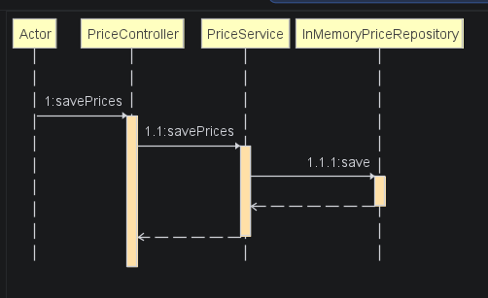

8.2) Retrieve Prices by Vendor
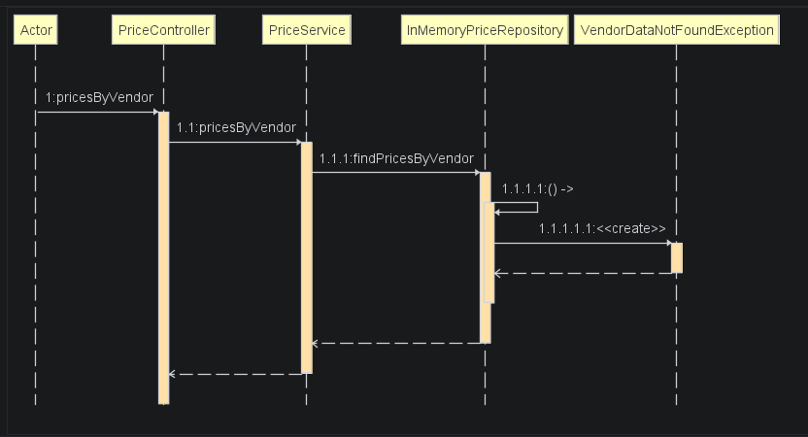

8.3) Retrieve Prices by Instrument
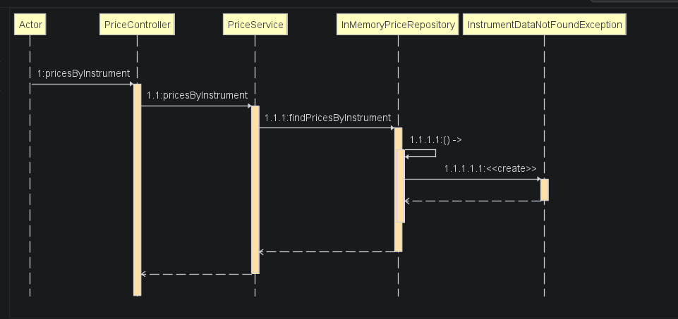

8.4) Eviction Flow
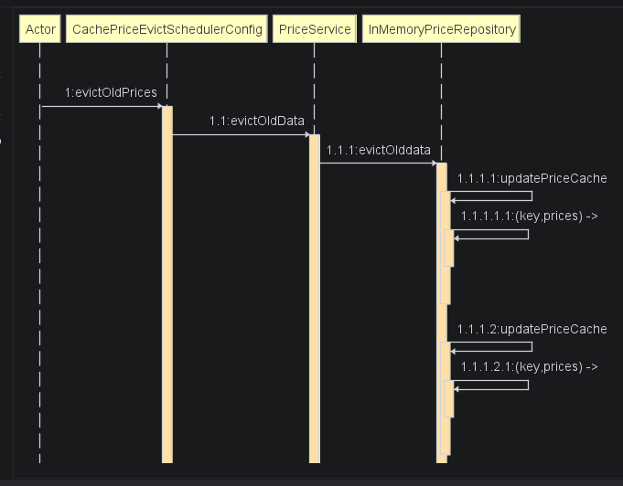

- Error Handling & Logging
Custom exception class created to handle Vendor & Instrument.
HttpStatus BAD_REQUEST and NOT_FOUND are handled
Log4j2 is used for logging.

- Scalability & Future Enhancements
For production ready solution replace in-memory map cache with REDIS database.
Downstream system notification can be handled using messaging systems to maintain data durability and data acknowledgement .
Implement ExecutorsService to handle async requests when the vendor base grows

